**JAVASCRIPT- AUTHENTICATION.**

1. Start the challenge.
2. Right- click.
3. Inspect the Network.

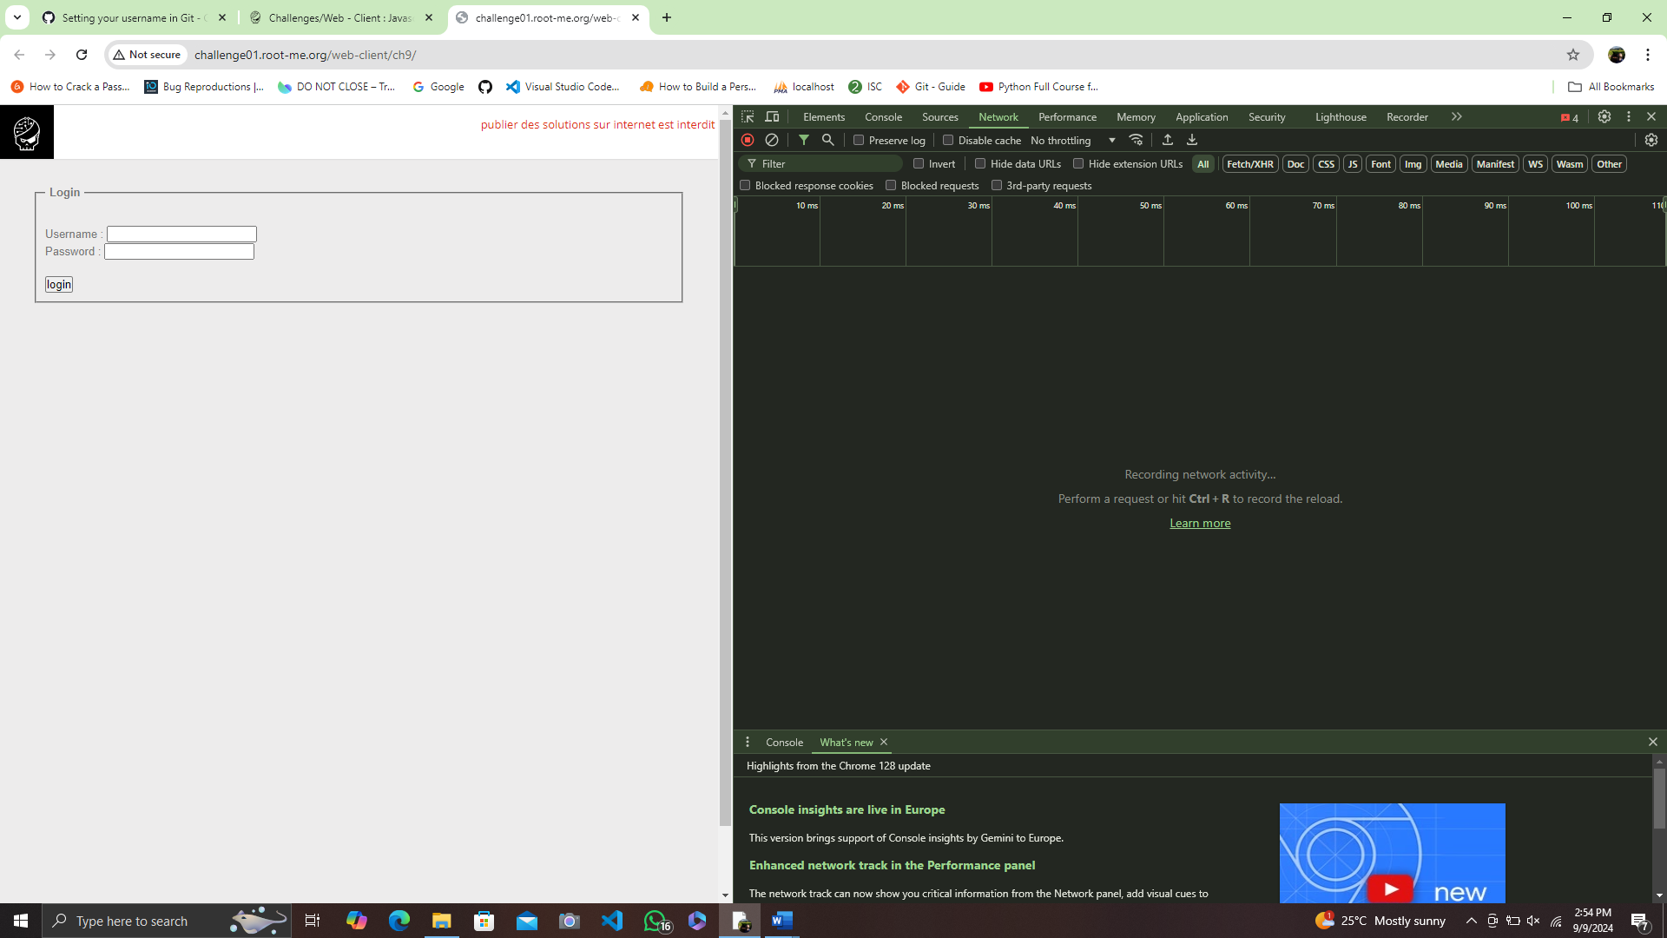

1. Refresh the webpage and locate any Javascript file

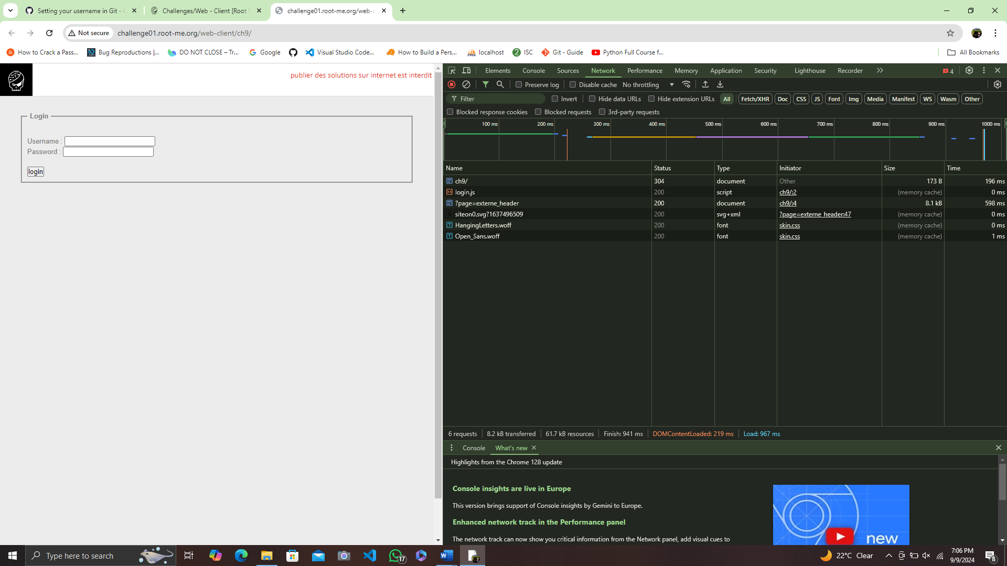

1. Double click the ‘login.js’ file to view it’s contents.

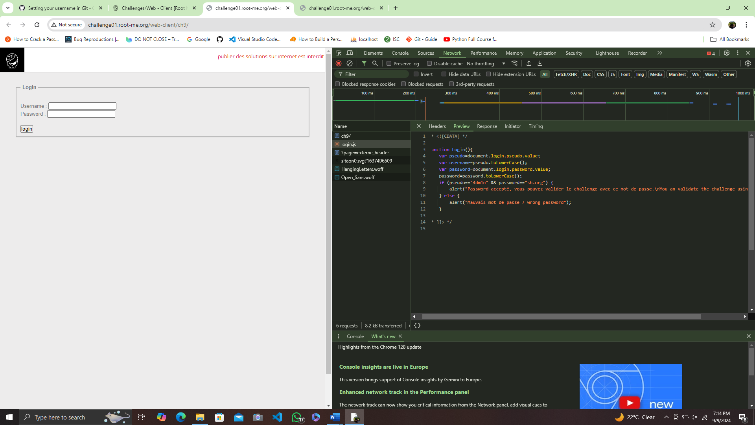

1. Input the visible username and password into the fields and login.

Username- 4dm1n

Password- sh.org

